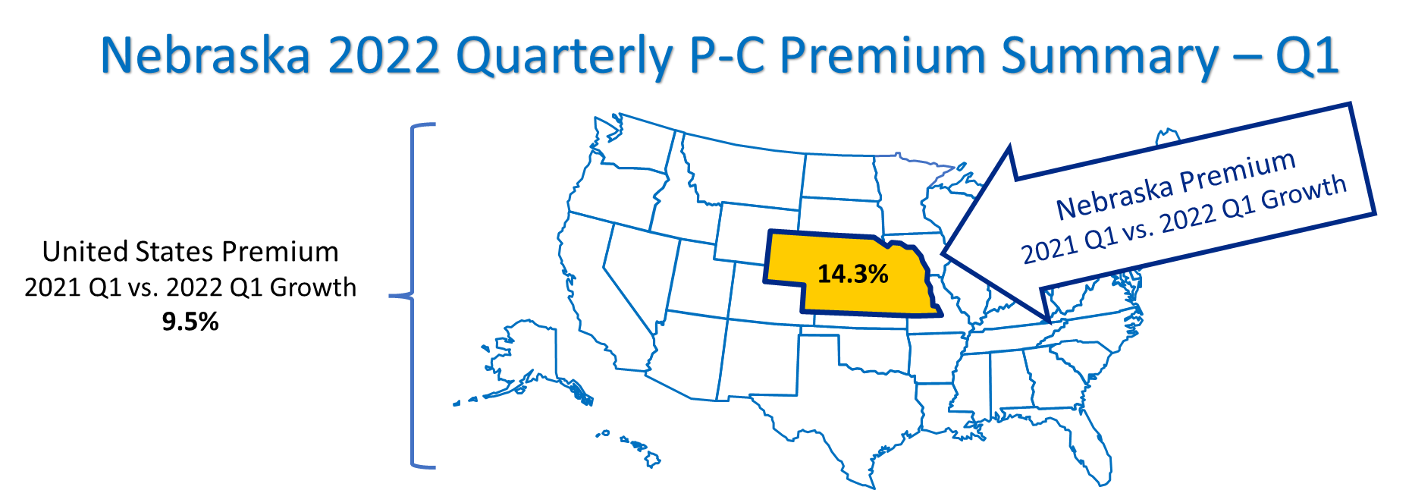
Figure 1
Source: © A.M. Best Company — Used by Permission
You are being provided this Nebraska 2022 Quarterly P-C Premium Summary – Q1 as a benefit of your membership in the Independent Insurance Agents of Nebraska. Quarterly premium data reveals trends to give you, as members, a more “real time” sense of market conditions. This quarterly Summary is intended as a compliment/update to the annual 2021 Nebraska P-C Marketplace Summary. This quarterly Summary is focused on premium trends only. And, as with the annual Summary, the quarterly Summary uses direct premiums, before reinsurance.
Below are the highlights from the most recent quarterly data.
- Premiums in Nebraska are growing faster than the United States in the short-term (2021 Q1 vs. 2022 Q1), medium-term (rolling 12-months), and long-term (4 years).
- Surplus lines growth rates in Nebraska are lower than the United States average in the short-, medium-, and long-term. However, the surplus lines growth rates exceed the all lines average growth rate in Nebraska.
- One trend is clear from the recent premium data and that is that insurers distributing through Independent Agents are growing premiums faster than those insurers focused on Direct or Exclusive-Captive distribution styles.
- When looking at lists of the top 50 insurers in Nebraska, the largest premium insurer is Farmers Mutual Insurance Co of Nebraska. The fastest growing insurer is Century Surety Company (AmeriTrust Group). Four insurers make both the largest premium and the fastest growing lists. Sixty percent (60%) of the largest insurers, and 90% of the fastest growing, use Independent Agent distribution. In Nebraska, for the largest premium insurers, Private Passenger Auto is the line of business with the most premiums for those insurers. For the fastest-growing insurers, it is Other Liability (Occurrence).
- The line of business growing the fastest in the United States in the most recent quarter is Burglary & Theft, the premiums of which grew at 24% in 2021 Q1 vs. 2022 Q1. Other lines where premiums are growing quickly are All Auto, E.C. Perils+Flood+Crop (the combination of line of business), and Other Liability (Claims-made).
More information on these highlights follows in this quarterly Summary. Data on premiums in Nebraska by distribution style and regulatory regime, and also lists of the top 50 insurers are provided. United States line of business data is included as well. Premium dollars are presented graphically with quarterly trends visible, and growth percentages shown in tables. Appendix #1 and Appendix #2 show how short-, medium-, and long-term percentages are calculated, and explain important differences and similarities between the annual Summary and this quarterly Summary.
Nebraska Quarterly Premiums vs. The United States

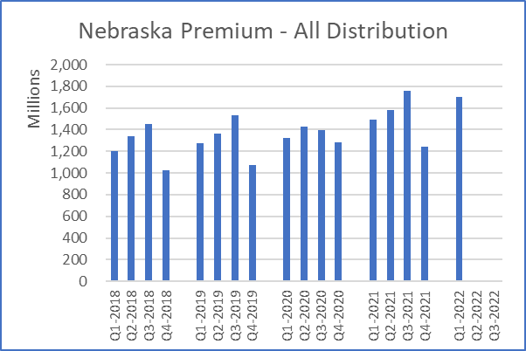 | 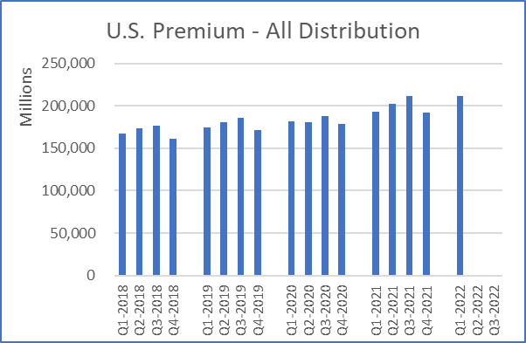
Figure 2 | Figure 3
Q1-to-Q1 Rolling Average  14.3% 12.3% 8.8%  2021 Premium: $6,073,080,000 | Q1-to-Q1 Rolling Average  9.5% 10.3% 5.9%  2021 Premium: $798,164,583,000
Table 2 | Table 3
Source: © A.M. Best Company — used by permission.
Notes:
Quarter-to-quarter premium growth trends can be visually observed in Figure 2 – Nebraska Premium - All Distribution and Figure 3 – U.S. Premium - All Distribution. The data below the bar charts, Table 2 and Table 3, provide the short-term (Q1-to-Q1), medium-term (Rolling 12-months), and long-term (Average 4 years) growth rates for Nebraska and the United States premiums. And, for perspective on the size of the Nebraska P-C insurance marketplace, total premiums for Nebraska and the United States are also provided within Tables 2 and 3. This is the same general approach to the figures and tables taken throughout the rest of this Nebraska 2022 Quarterly P-C Premium Summary – Q1. For detailed information on how the short-, medium- and long-term growth percentages are calculated, see Appendix #1 – Measuring Premium Growth.

Distribution Styles and Premiums
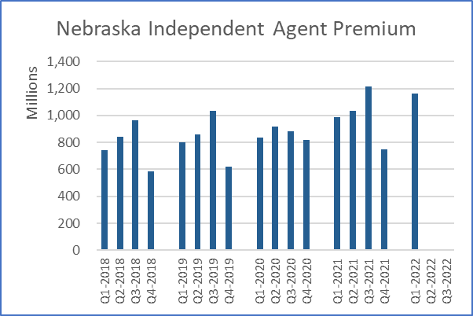 | 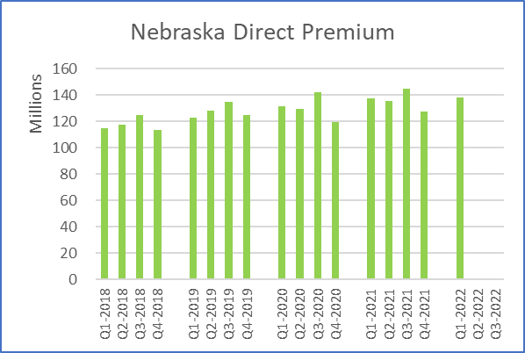 | 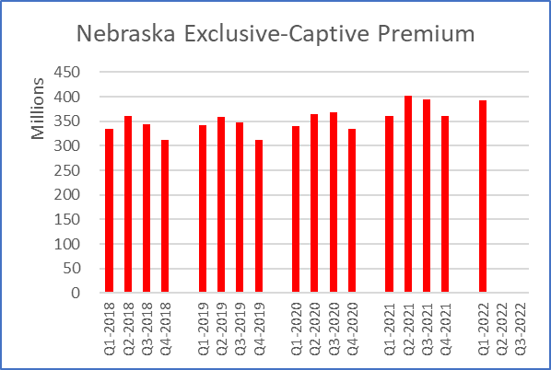
Figure 4 | Figure 5 | Figure 6
Q1-to-Q1 Rolling Average  18.0% 15.4% 11.3%  2021 Premium: $3,986,563,000 | Q1-to-Q1 Rolling Average  0.5% 3.3% 4.7%  2021 Premium: $546,138,000 | Q1-to-Q1 Rolling Average  8.7% 8.4% 4.0%  2021 Premium: $1,515,328,000
Table 4 | Table 5 | Table 6

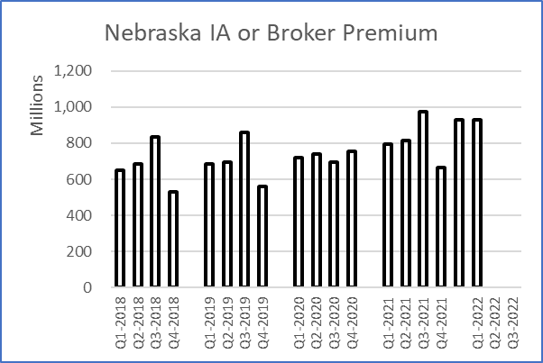 | 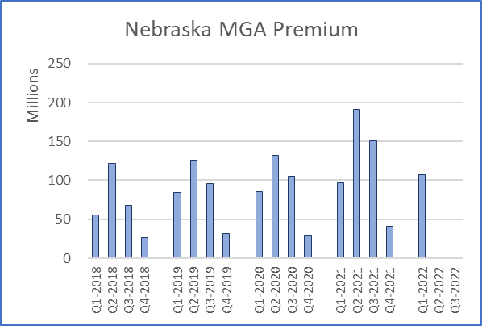 | 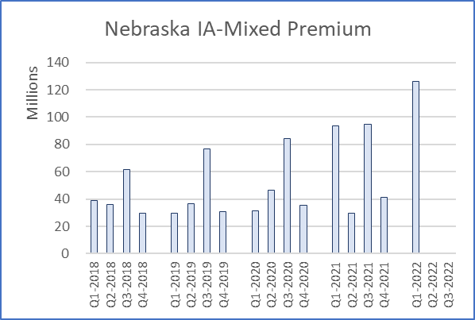
Figure 7 | Figure 8 | Figure 9
Q1-to-Q1 Rolling Average  16.7% 44.4% 9.0%  2021 Premium: $3,247,938,000 | Q1-to-Q1 Rolling Average  11.5% 35.2% 16.8%  2021 Premium: $479,436,000 | Q1-to-Q1 Rolling Average  35.1% 12.4% 30.7%  2021 Premium: $259,189,000
Table 7 | Table 8 | Table 9

United States Premium Growth-Percentage Comparisons
United States | Independent Agent | Direct | Exclusive-Captive | IA or Broker | MGA | IA-Mixed
Q1-to-Q1 | 11.8% | 4.0% | 7.4% | 10.5% | 19.9% | 14.4%
Rolling | 13.1% | 34.2% | 6.4% | 40.5% | 21.6% | 15.6%
Average | 7.6% | 4.5% | 2.5% | 6.5% | 14.8% | 11.1%
Table 10
Source: © A.M. Best Company — used by permission.
Notes:
Distribution styles shown above are based on insurer “Marketing Types.” Figures and Tables 4-6 show the main distribution styles P-C insurers use to sell their policies. Figures 4-6 visually show the actual quarterly premium dollars for Nebraska Independent Agent distribution, insurers using Direct distribution, and insurers using Exclusive-Captive distribution. Tables 4-6 show the exact percentage growth rates for these distribution styles for Nebraska, and for perspective, the premiums for each distribution style are provided within those tables. Next, shown in Figures and Tables 7-9, are the components of the insurers classified as using Independent Agents, which are insurers using purely IA or Broker, MGAs (also called general agents and wholesalers), and insurers using independent agents with other types of marketing. Table 10 shows comparison percentages for the United States. Information on the classification of insurers into distribution styles is contained in Appendix #2 – Annual vs. Quarterly P-C Summaries.
Regulation and Premiums: Admitted, E&S and RRGs
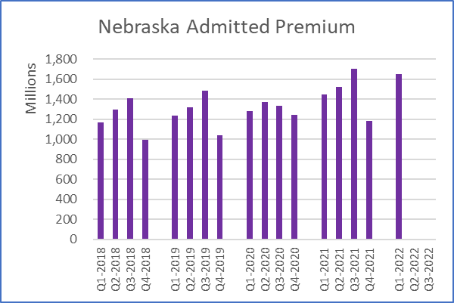 | 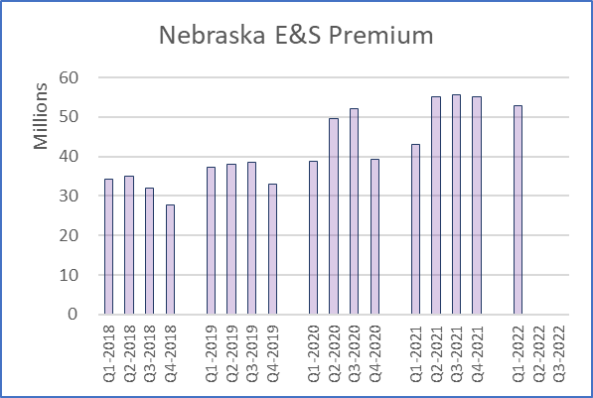 | 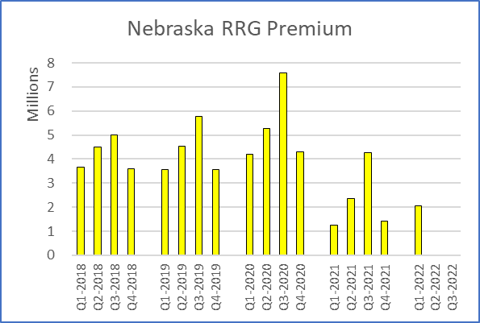
Figure 11 | Figure 12 | Figure 13
Q1-to-Q1 Rolling Average  14.0% 12.3% 8.7%  2021 Premium: $5,855,067,000 | Q1-to-Q1 Rolling Average  22.9% 18.7% 11.1%  2021 Premium: $208,724,000 | Q1-to-Q1 Rolling Average  63.9% -45.1% -14.2%  2021 Premium: $9,289,000
Table 11 | Table 12 | Table 13

United States Premium Growth- Percentage Comparisons
United States | Admitted | E&S | RRGs
Q1-to-Q1 | 8.2% | 27.1% | 7.7%
Rolling | 8.8% | 29.7% | 12.9%
Average | 5.0% | 18.3% | 8.5%
Table 14
Source: © A.M. Best Company — used by permission.
Notes:
Figures and Tables 11-13 show the Nebraska premiums broken out into the predominant regulatory regime applying to the insurer. The premiums shown in Figures 11-13 are the sum of the individual insurers classified as Admitted, E&S, and Risk Retention Groups. Admitted insurers are the most closely regulated for solvency, rates, and forms and are generally covered by the state guaranty fund. E&S insurers are less regulated and called excess & surplus lines, surplus lines or non-admitted. And, Risk Retention Groups are subject to a combination of federal and state rules and regulations and are often referred to as RRGs. The percentage growth rates for Nebraska and each regulatory regime are presented in Tables 11-13 with total premiums applicable. Table 14 shows comparison percentages for the United States.

It is important to note that for the particular set of data in Figures 11-13, the vertical axis for each bar chart varies in the maximum dollars, as the intent is to show relative changes in premiums and quarterly differences. If a single maximum were used (for example in millions of dollars only), then premium variations would be less visible, or not visible at all.

Composite Percentages: All, by Distribution, and by Regulation
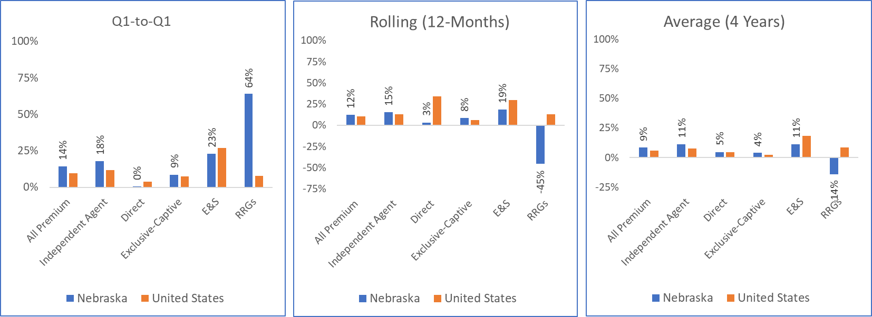
Figure 15 | Figure 16 | Figure 17

Composite Premium Growth Percentages for Figures 15-17
All, Distribution or  Regulatory Regime | Q1-to-Q1 |  | Rolling (12-Months) |  | Average (4 Years)
 | Nebraska | U.S. | Nebraska | U.S. | Nebraska | U.S.
All Premium | 14.3% | 9.5% | 12.3% | 10.3% | 8.8% | 5.9%
Independent Agent | 18.0% | 11.8% | 15.4% | 13.1% | 11.3% | 7.6%
IA or Broker | 16.7% | 10.5% | 44.4% | 40.5% | 9.0% | 6.5%
MGA | 11.5% | 19.9% | 35.2% | 21.6% | 16.8% | 14.8%
IA-Mixed | 35.1% | 14.4% | 12.4% | 15.6% | 30.7% | 11.1%
Direct | 0.5% | 4.0% | 3.3% | 34.2% | 4.7% | 4.5%
Capt-Excl | 8.7% | 7.4% | 8.4% | 6.4% | 4.0% | 2.5%
Other | 65.1% | 6.3% | -9.0% | -0.9% | -3.1% | 1.3%
E&S | 22.9% | 27.1% | 18.7% | 29.7% | 11.1% | 18.3%
RRGs | 63.9% | 7.7% | -45.1% | 12.9% | -14.2% | 8.5%
Admitted | 14.0% | 8.2% | 12.3% | 8.8% | 8.7% | 5.0%
Table 15
Source: © A.M. Best Company — used by permission.
Notes:
Figures 15-17 give a comparison of Nebraska to the United States in a side-by-side manner for all premiums, selected distribution styles, and selected regulatory regimes. Table 15 provides the growth percentages for Nebraska and United States, as more precise percentages are not conducive to display in Figures 15-17. You will also notice that Table 15 contains additional growth percentages for Admitted, IA or Broker, MGA and IA-Mixed.

Top 50: Largest and Fastest Growing Insurers
The following pages contain quarterly data for the 50 largest and fastest growing insurers.
Table 16 – Nebraska: Top 50 Largest Insurers-Growth, Premiums, Marketing Type, and Biggest Line of Business is provided to highlight the largest insurers. Table 16 is sorted in descending order of each insurer’s rolling 12-month premium dollars.
Table 17 – Nebraska: Top 50 Fastest Growing Insurers-Growth, Premiums, Marketing Type, and Biggest Line of Business is provided to highlight those insurers with the highest growth rates. Table 17 is sorted by the average premium growth rate over the past 4 years.
If a Top 50 largest insurer in Table 16 is also a Top 50 fastest growing insurer seen in Table 17, it is highlighted in Table 16 with green shading and bold text. At the bottom of Table 16 and Table 17 is the sum-total of all the premiums of all 50 insurers listed, as well as the weighted average of the growth rates.
In both tables attributes and data on each insurer are provided. First is the policy-issuing insurer’s group or fleet, if any. Second is the annualized premiums for the preceding rolling 12-months (4 quarters). Third is the marketing type(s) listed by the insurer. Fourth is the insurer’s largest line of business. Last is the 3 measures of growth in premiums for each insurer.
Take note that the insurers shown are individual policy-issuing insurers, and not broader groups or the brand you might associate with an insurer. Within insurer groups some policy-issuing insurers can grow faster or slower than the overall group, or other insurers in the group. Also, note that the largest line of business for each insurer shown in Table 16 and Table 17 are based on the United States line of business premiums for 2021. The line of business listed as largest may not be the largest line of business in Nebraska for that insurer, or the largest line in this most recent quarter. The ranking of lines of business for an insurer in Nebraska can be determined from the annual data, but not from the quarterly data.
How to use this information
Look for premium trends regarding competitors, or for the insurers you use. Examine what line of business is most important to the insurer. The fastest growing insurers might be recent competitors formed in the “insurtech” sphere, or insurers in the trade press. Or, they might be markets for you to investigate gaining access to through a program administrator, MGA, or via a direct appointment.

Nebraska: Top 50 Largest Insurers-Growth, Premiums, Marketing Type, and Biggest Line of Business
Nebraska Largest Insurers |  | Group | Premium  ($000) | Marketing Type | Largest Line of Business (U.S. Total) | Average  Growth | Rolling  Growth | Q1-to-Q1 Growth
1 | Farmers Mutual Insurance Co of Nebraska | ... | $374,074 | Independent Agency | All Private Passenger Auto | 5% | 8% | 10%
2 | State Farm Fire and Casualty Company | State Farm Group | $323,698 | Exclusive/Captive Agent | Homeowners Mult Peril | 4% | 10% | 10%
3 | Rural Community Insurance Company | Zurich Insurance US PC Group | $302,799 | Managing General Agent | Mult Peril Crop | 152% | 68% | G.T. +200%
4 | State Farm Mutual Automobile Ins Co | State Farm Group | $277,368 | Exclusive/Captive Agent | All Private Passenger Auto | 0% | 4% | 6%
5 | NAU Country Insurance Company | QBE North America Insurance Group | $268,296 | Independent Agency | Mult Peril Crop | 25% | 35% | 42%
6 | Farm Bureau Property & Casualty Ins Co | Farm Bureau Property & Casualty Group | $230,589 | Exclusive/Captive Agent | All Private Passenger Auto | 2% | 7% | 8%
7 | Progressive Northern Insurance Company | Progressive Insurance Group | $194,172 | Independent Agency | All Private Passenger Auto | 10% | 7% | 6%
8 | ACE Property and Casualty Insurance Co | Chubb INA Group | $165,807 | Independent Agency | Mult Peril Crop | * | 40% | G.T. +200%
9 | American Agri-Business Insurance Company | Sompo Holdings US Group | $161,873 | Other Agency | Mult Peril Crop | 49% | 7% | 46%
10 | American Family Mutual Ins Co, S.I. | American Family Insurance Group | $107,205 | Exclusive/Captive Agent | All Private Passenger Auto | -6% | 2% | -4%
11 | Nationwide Mutual Insurance Company | Nationwide Group | $105,943 | Exclusive/Captive Agent | All Private Passenger Auto | 25% | 31% | 27%
12 | American Family Insurance Company | American Family Insurance Group | $96,059 | Exclusive/Captive Agent | All Private Passenger Auto | 16% | 22% | 18%
13 | Progressive Universal Insurance Company | Progressive Insurance Group | $94,767 | Direct Response | All Private Passenger Auto | 11% | 8% | 9%
14 | Great American Insurance Company | Great American P & C Insurance Group | $80,740 | Independent Agency | Mult Peril Crop | 10% | 31% | 35%
15 | Farmers Mutual Hail Insurance Co of Iowa | FMH Insurance Group | $73,968 | Independent Agency | Mult Peril Crop | 5% | 38% | 18%
16 | Great West Casualty Company | Old Republic Insurance Group | $67,137 | Independent Agency | All Commercial Auto | -10% | 9% | 11%
17 | Employers Mutual Casualty Company | EMC Insurance Companies | $67,037 | Independent Agency | All Commercial Auto | -1% | 1% | 1%
18 | Allstate Fire and Casualty Insurance Co | Allstate Insurance Group | $62,040 | Exclusive/Captive Agent | All Private Passenger Auto | 11% | 18% | 17%
19 | Stratford Insurance Company | American International Group | $59,799 | General Agent | Mult Peril Crop | -10% | -17% | -61%
20 | North Star Mutual Insurance Company | North Star Companies | $59,444 | Independent Agency | All Private Passenger Auto | 11% | 12% | 14%
21 | Travelers Property Casualty Co of Amer | Travelers Group | $58,003 | Independent Agency | Other Liab (Occurrence) | 4% | 5% | -3%
22 | Auto-Owners Insurance Company | Auto-Owners Insurance Group | $55,850 | Independent Agency | Homeowners Mult Peril | 12% | 10% | 11%
23 | United Services Automobile Association | USAA Group | $53,818 | Direct Response | All Private Passenger Auto | 4% | 2% | 2%
24 | Western Agricultural Insurance Company | Farm Bureau Property & Casualty Group | $52,784 | Exclusive/Captive Agent, Managing General Agent | Mult Peril Crop | 4% | 20% | 15%
25 | Owners Insurance Company | Auto-Owners Insurance Group | $52,048 | Independent Agency | All Private Passenger Auto | 14% | 11% | 11%
26 | Shelter Mutual Insurance Company | Shelter Insurance Companies | $46,000 | Exclusive/Captive Agent | All Private Passenger Auto | 4% | 6% | 8%
27 | GEICO Advantage Insurance Company | Berkshire Hathaway Insurance Group | $44,894 | Direct Response | All Private Passenger Auto | 8% | 16% | 5%
28 | Zurich American Insurance Company | Zurich Insurance US PC Group | $44,836 | Independent Agency | All Commercial Auto | 10% | 13% | 49%
29 | Battle Creek Mutual Insurance Company | Nodak Insurance Group | $44,301 | Independent Agency | Homeowners Mult Peril | 6% | 6% | 10%
30 | Federal Insurance Company | Chubb INA Group | $43,466 | Independent Agency | Other Liab (Claims-made) | 18% | 23% | 24%
31 | Nationwide Insurance Company of America | Nationwide Group | $43,156 | Independent Agency | All Private Passenger Auto | 53% | 7% | -9%
32 | Allstate Vehicle and Property Ins Co | Allstate Insurance Group | $41,347 | Independent Agency | Homeowners Mult Peril | 19% | 19% | 19%
33 | Liberty Insurance Underwriters, Inc. | Liberty Mutual Insurance Companies | $40,302 | Exclusive/Captive Agent, Direct Response | Inland Marine | 4% | 10% | 11%
34 | Nationwide Agribusiness Insurance Co | Nationwide Group | $39,774 | Direct Response | Farmowners Mult Peril | -13% | -6% | -10%
35 | AXIS Insurance Company | AXIS US Operations | $38,026 | Broker | Other Liab (Claims-made) | -18% | -35% | -39%
36 | AMCO Insurance Company | Nationwide Group | $37,486 | Independent Agency | Commercial Multiple Peril (Total) | -10% | -7% | 8%
37 | Cincinnati Insurance Company | The Cincinnati Insurance Companies | $36,332 | Independent Agency | Commercial Multiple Peril (Total) | 8% | 15% | 18%
38 | Farmers Insurance Exchange | Farmers Insurance Group | $35,893 | Exclusive/Captive Agent | All Private Passenger Auto | 11% | 8% | 13%
39 | USAA Casualty Insurance Company | USAA Group | $32,379 | Direct Response | All Private Passenger Auto | 7% | 3% | 1%
40 | Mid-Century Insurance Company | Farmers Insurance Group | $31,528 | Exclusive/Captive Agent | All Private Passenger Auto | -2% | 1% | -1%
41 | Standard Fire Insurance Company | Travelers Group | $30,860 | Independent Agency | All Private Passenger Auto | 8% | 9% | 12%
42 | USAA General Indemnity Company | USAA Group | $30,781 | Direct Response | All Private Passenger Auto | 5% | 1% | 0%
43 | Travelers Personal Insurance Company | Travelers Group | $30,681 | Independent Agency | Homeowners Mult Peril | * | 25% | 28%
44 | Nationwide Property & Casualty Ins Co | Nationwide Group | $29,820 | Exclusive/Captive Agent | All Private Passenger Auto | * | 9% | -7%
45 | Acuity, A Mutual Insurance Company | ... | $29,249 | Independent Agency | All Commercial Auto | 10% | 6% | 3%
46 | Factory Mutual Insurance Company | FM Global Group | $26,404 | Direct Response, Broker | Allied Lines | -7% | 32% | -4%
47 | Continental Casualty Company | CNA Insurance Companies | $26,375 | Independent Agency | Inland Marine | -3% | -9% | -13%
48 | Producers Agriculture Insurance Company | Tokio Marine US PC Group | $26,163 | Broker | Mult Peril Crop | 55% | 100% | G.T. +200%
49 | GEICO Choice Insurance Company | Berkshire Hathaway Insurance Group | $25,410 | Direct Response | All Private Passenger Auto | 4% | 8% | 0%
50 | ACE American Insurance Company | Chubb INA Group | $24,107 | Independent Agency | Commercial Multiple Peril (Total) | 12% | 18% | 58%
N/A | Top 50 Total Premium or Average Growth | N/A | $4,324,888 | N/A | N/A | 19% | 17% | 11%
Table 16 | Source: © A.M. Best Company — used by permission | “*” indicates a zero ($0) or negative quarterly premium figure in one or more quarters
Nebraska: Top 50 Fastest Growing Insurers-Growth, Premiums, Marketing Type, and Biggest Line of Business
Nebraska Fastest Growing Insurers |  | Group | Premium  ($000) | Marketing Type | Largest Line of Business (U.S. Total) | Average  Growth | Rolling  Growth | Q1-to-Q1 Growth
1 | Century Surety Company | AmeriTrust Group | $1,103 | General Agent, Broker | Other Liab (Occurrence) | 168% | 20% | 3%
2 | Rural Community Insurance Company | Zurich Insurance US PC Group | $302,799 | Managing General Agent | Mult Peril Crop | 152% | 68% | G.T. +200%
3 | Clear Spring Property & Casualty Company | Group 1001 Property and Casualty Group | $744 | Broker | All Private Passenger Auto | 126% | 150% | 79%
4 | Clear Blue Specialty Insurance Company | Clear Blue Insurance Group | $2,289 | Managing General Agent | Other Liab (Occurrence) | 121% | G.T. +200% | G.T. +200%
5 | Allied World National Assurance Company | Fairfax Financial (USA) Group | $1,247 | Broker | Other Liab (Occurrence) | 118% | -29% | -1%
6 | American Economy Insurance Company | Liberty Mutual Insurance Companies | $6,234 | Independent Agency | Homeowners Mult Peril | 114% | G.T. +200% | G.T. +200%
7 | Integon National Insurance Company | Allstate Insurance Group | $100 | Independent Agency | All Private Passenger Auto | 106% | 54% | 169%
8 | Professional Solutions Ins Co | NCMIC Group | $281 | Broker, General Agent | Other Liab (Claims-made) | 106% | 175% | G.T. +200%
9 | American National Lloyds Insurance Co | American National Prop & Cas Group | $1,951 | Exclusive/Captive Agent | Commercial Multiple Peril (Total) | 104% | 43% | 9%
10 | Spinnaker Insurance Company | Spinnaker Insurance Group | $1,776 | Managing General Agent | Homeowners Mult Peril | 103% | 178% | 115%
11 | Occidental Fire and Casualty Co of NC | IAT Insurance Group | $252 | General Agent | Homeowners Mult Peril | 101% | 81% | L.T. -100%
12 | American Southern Home Insurance Company | Munich-American Holding Corp Companies | $121 | Independent Agency | Commercial Multiple Peril (Total) | 95% | G.T. +200% | G.T. +200%
13 | Lyndon Southern Insurance Company | Fortegra P&C Group | $1,445 | Independent Agency | Inland Marine | 94% | 21% | -4%
14 | Midvale Indemnity Company | American Family Insurance Group | $3,426 | Other | Commercial Multiple Peril (Total) | 92% | 36% | 56%
15 | Mitsui Sumitomo Insurance USA Inc. | MS&AD US Insurance Group | $291 | Broker, Independent Agency | Commercial Multiple Peril (Total) | 91% | 14% | 37%
16 | Century-National Insurance Company | Allstate Insurance Group | $83 | Independent Agency | Homeowners Mult Peril | 87% | 6% | -39%
17 | Travelers Excess and Surplus Lines Co | Travelers Group | $6,989 | Broker | Other Liab (Claims-made) | 86% | 57% | G.T. +200%
18 | Universal Underwriters Insurance Company | Zurich Insurance US PC Group | $1,806 | Direct Response | Other Liab (Occurrence) | 85% | 30% | 2%
19 | Lancer Insurance Company | Core Specialty Insurance Group | $248 | Broker | All Commercial Auto | 81% | 77% | 36%
20 | Motorists Commercial Mutual Insurance Co | Encova Mutual Insurance Group | $20,781 | Independent Agency | Commercial Multiple Peril (Total) | 80% | 16% | 9%
21 | United National Insurance Company | Global Indemnity Group | $1,274 | General Agent, Managing General Agent | Other Liab (Occurrence) | 78% | 50% | 187%
22 | Citizens Insurance Company of America | Hanover Ins Group Prop & Cas Cos | $223 | Independent Agency | Commercial Multiple Peril (Total) | 77% | 156% | G.T. +200%
23 | Austin Mutual Insurance Company | American Family Insurance Group | $13,959 | Independent Agency | All Commercial Auto | 74% | 52% | 96%
24 | Intrepid Insurance Company | W. R. Berkley Insurance Group | $1,149 | Direct Response, Independent Agency | Commercial Multiple Peril (Total) | 72% | 101% | 170%
25 | NORCAL Insurance Company | ProAssurance Group | $81 | Independent Agency, Broker | Medical Professional Liability | 70% | 5% | 18%
26 | Mitsui Sumitomo Insurance Co of America | MS&AD US Insurance Group | $725 | Broker, Independent Agency | Allied Lines | 68% | 54% | L.T. -100%
27 | GuideOne Specialty Insurance Company | GuideOne Insurance Companies | $206 | Independent Agency | Commercial Multiple Peril (Total) | 68% | 186% | 9%
28 | Endurance Assurance Corporation | Sompo Holdings US Group | $1,489 | Not Available | Other Liab (Occurrence) | 67% | G.T. +200% | G.T. +200%
29 | Gemini Insurance Company | W. R. Berkley Insurance Group | $11,550 | Managing General Agent | Other Liab (Occurrence) | 67% | 21% | 52%
30 | Berkshire Hathaway Direct Insurance Co | Berkshire Hathaway Insurance Group | $1,279 | Independent Agency, Direct Response | Commercial Multiple Peril (Total) | 66% | 38% | 19%
31 | Benchmark Insurance Company | Benchmark Insurance Group | $1,750 | Managing General Agent, Direct Response | All Commercial Auto | 66% | G.T. +200% | G.T. +200%
32 | Starr Surplus Lines Insurance Company | Starr International Group | $7,701 | Independent Agency | Fire | 65% | 3% | -16%
33 | General Insurance Company of America | Liberty Mutual Insurance Companies | $622 | Independent Agency | Homeowners Mult Peril | 62% | 33% | 24%
34 | Crestbrook Insurance Company | Nationwide Group | $17,185 | Direct Response | Homeowners Mult Peril | 62% | 74% | -25%
35 | Berkley Casualty Company | W. R. Berkley Insurance Group | $235 | Independent Agency | All Commercial Auto | 61% | 15% | G.T. +200%
36 | Accredited Surety and Casualty Co, Inc. | Randall Group | $101 | Independent Agency | Other Liab (Occurrence) | 56% | * | **
37 | Diamond Insurance Company | ... | $46 | Independent Agency | Aircraft(all perils) | 56% | -42%
38 | Imperium Insurance Company | Skyward Specialty Insurance Group | $647 | General Agent, Managing General Agent | All Commercial Auto | 55% | 15% | 21%
39 | Producers Agriculture Insurance Company | Tokio Marine US PC Group | $26,163 | Broker | Mult Peril Crop | 55% | 100% | G.T. +200%
40 | Metropolitan General Insurance Company | ... | $135 | Independent Agency, Career Agent | All Private Passenger Auto | 54% | G.T. +200% | G.T. +200%
41 | Nationwide Insurance Company of America | Nationwide Group | $43,156 | Independent Agency | All Private Passenger Auto | 53% | 7% | -9%
42 | Mid-Continent Assurance Company | Great American P & C Insurance Group | $28 | Independent Agency | All Commercial Auto | 51% | G.T. +200% | *
43 | Crum & Forster Specialty Insurance Co | Fairfax Financial (USA) Group | $3,608 | Broker | Other Liab (Occurrence) | 50% | 29% | 100%
44 | North River Insurance Company | Fairfax Financial (USA) Group | $2,243 | Independent Agency | Other Liab (Occurrence) | 50% | G.T. +200% | 124%
45 | American Agri-Business Insurance Company | Sompo Holdings US Group | $161,873 | Other Agency | Mult Peril Crop | 49% | 7% | 46%
46 | The Hanover American Insurance Company | Hanover Ins Group Prop & Cas Cos | $130 | Independent Agency | Commercial Multiple Peril (Total) | 49% | G.T. +200% | G.T. +200%
47 | AmTrust Insurance Company | AmTrust Group | $545 | Independent Agency | All Commercial Auto | 48% | -35% | -86%
48 | AIX Specialty Insurance Company | Hanover Ins Group Prop & Cas Cos | $988 | Independent Agency, Managing General Agent | Other Liab (Occurrence) | 48% | 166% | G.T. +200%
49 | Aegis Security Insurance Company | LD Investments Group | $175 | Independent Agency, General Agent | Homeowners Mult Peril | 47% | -8% | -71%
50 | StarStone National Insurance Company | Core Specialty Insurance Group | $1,572 | Independent Agency, Managing General Agent | Other Liab (Occurrence) | 47% | 151% | 6%
N/A | Top 50 Total Premium or Average Growth | N/A | $654,804 | N/A | N/A | 102% | 45% | 16%
Table 17 | Source: © A.M. Best Company — used by permission | “*” indicates a zero ($0) or negative quarterly premium figure in one or more quarters

Lines of Business Compared
Lines of Business Growth Percentages – United States
What follows in Figures 18-20 is United States line of business growth rate percentages. Data is not available quarterly for lines of business on a state-specific basis. While not perfectly representative of line of business trends in Nebraska, United States data is useful for Nebraska agents to know, as generally there is a strong correlation in each state to United States line of business trends.
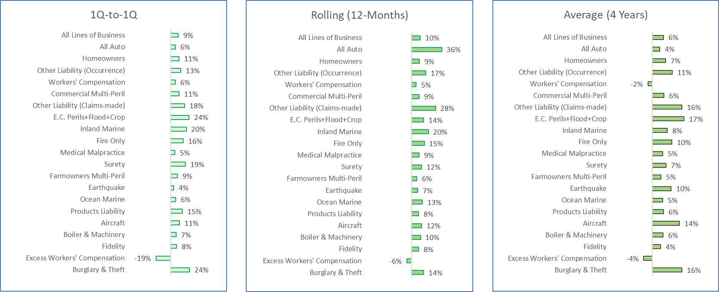
Figure 18 | Figure 19 | Figure 20
Source: © A.M. Best Company — used by permission.
Individual Lines of Business – United States
Provided on the following pages, for greater insights on each line of business beyond growth rates, is a breakout view of quarterly premiums for each line of business, with the 3 measures of growth: short-term (Q1-to-Q1), medium-term (Rolling 12-Months), and long-term (Average 4 Years). Total premiums for 2021 for each line of business are also provided under each figure.
For perspective, all lines of business are combined and shown together in Figure 21 – Premium: All Lines of Business and its corresponding Table 21. It is provided as a base-line reference for each line of business breakouts that follow in Figures and Tables 22-44.
Figures and Tables 22-43 give premium data for the various lines of business that agents focus on, as reported quarterly. The lines of business are listed in order of highest total premiums in dollars (All Auto) to least (International). Following the agent-focused lines of business, listed last as Figure 44, is Non-Agent Lines combined. Non-agent lines include smaller lines independent agents do not focus on, such as credit, dental, medical supplement, and warranties.

All Lines Premium – For Perspective
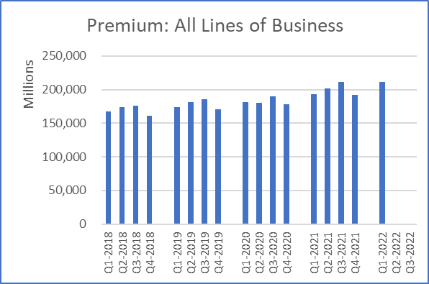
Figure 21
Q1-to-Q1 | Rolling | Average
9.5% | 10.1% | 5.9%
2021 Premium: $798,849,370,000

Table 21
Line of Business Breakout
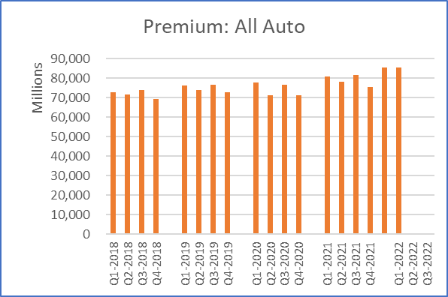 | 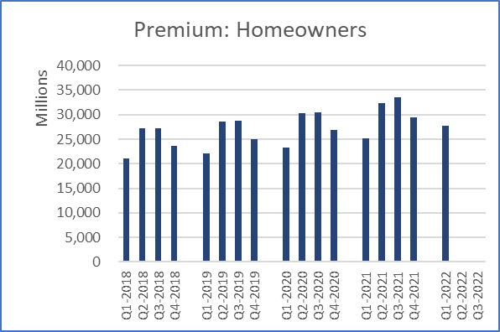 | 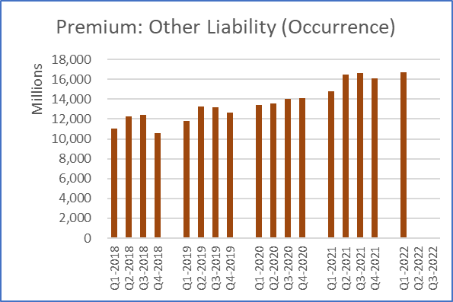
Figure 22 | Figure 23 | Figure 24
Q1-to-Q1 Rolling Average  5.8% 35.6% 4.0%  2021 Premium: $315,572,365,000 | Q1-to-Q1 Rolling Average  10.6% 9.2% 7.1%  2021 Premium: $120,426,305,000 | Q1-to-Q1 Rolling Average  12.9% 16.6% 10.6%  2021 Premium: $64,099,480,000
Table 22 | Table 23 | Table 24
Line of Business Breakout
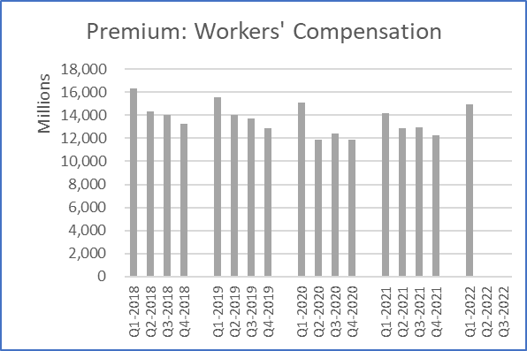 | 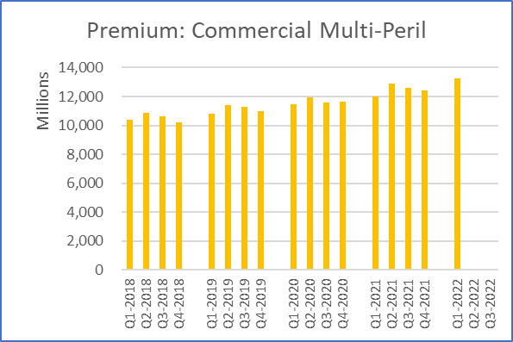 | 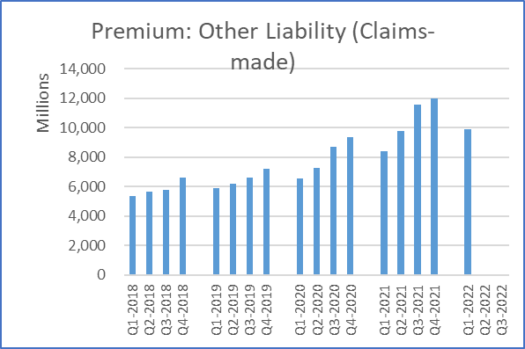
Figure 25 | Figure 26 | Figure 27
Q1-to-Q1 Rolling Average  5.7% 5.4% -2.1%  2021 Premium: $52,248,006,000 | Q1-to-Q1 Rolling Average  10.6% 8.7% 6.2%  2021 Premium: $49,961,427,000 | Q1-to-Q1 Rolling Average  17.9% 28.2% 15.7%  2021 Premium: $41,736,006,000
Table 25 | Table 26 | Table 27
Line of Business Breakout
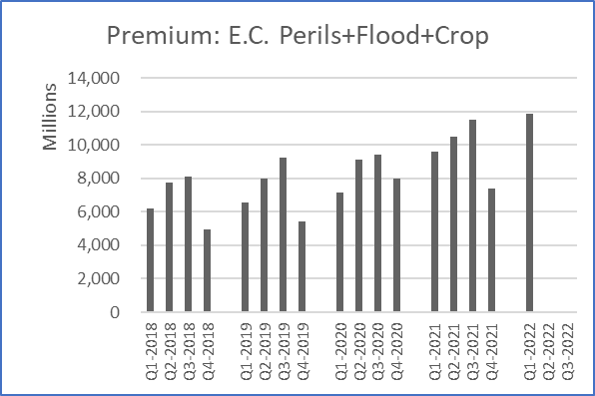 | 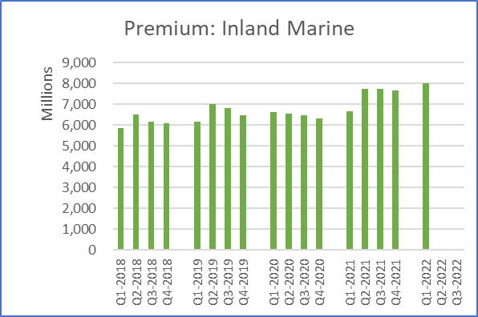 | 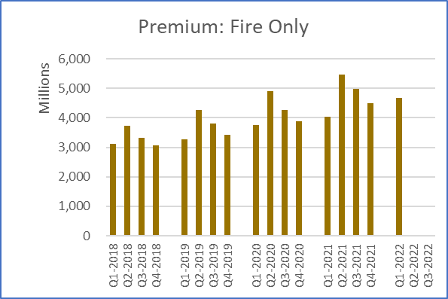
Figure 29 | Figure 30 | Figure 31
Q1-to-Q1 Rolling Average  23.6% 14.2% 16.6%  2021 Premium: $38,995,822,000 | Q1-to-Q1 Rolling Average  20.1% 19.8% 7.9%  2021 Premium: $29,813,382,000 | Q1-to-Q1 Rolling Average  16.2% 14.9% 10.3%  2021 Premium: $18,969,195,000
Table 29 | Table 30 | Table 31
Line of Business Breakout
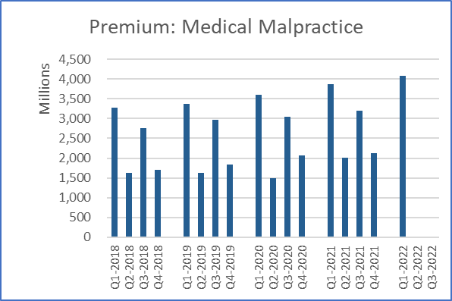 | 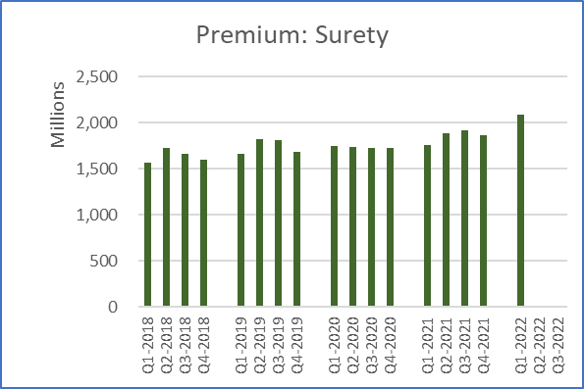 | 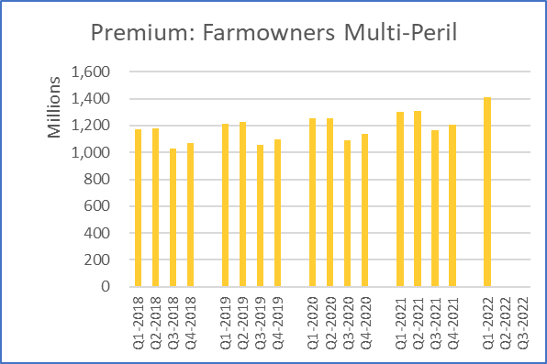
Figure 32 | Figure 33 | Figure 34
Q1-to-Q1 Rolling Average  5.2% 8.9% 5.5%  2021 Premium: $11,200,292,000 | Q1-to-Q1 Rolling Average  18.8% 11.7% 7.3%  2021 Premium: $7,438,276,000 | Q1-to-Q1 Rolling Average  8.5% 6.3% 4.7%  2021 Premium: $4,979,524,000
Table 32 | Table 33 | Table 34
Line of Business Breakout
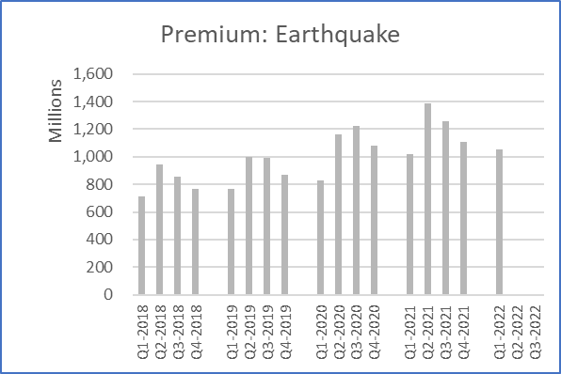 | 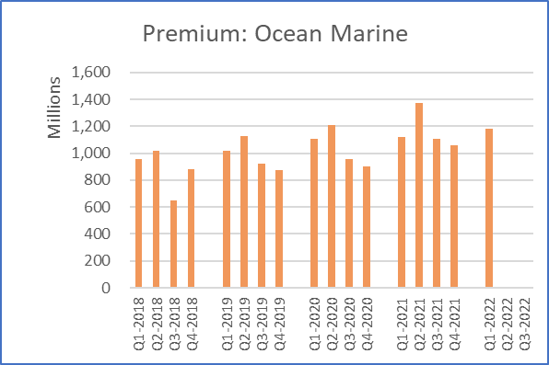 | 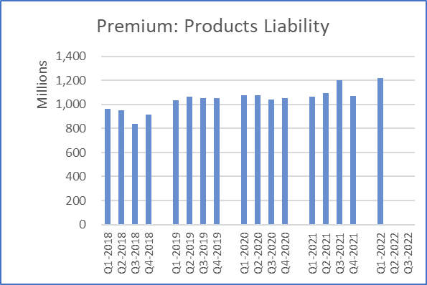
Figure 35 | Figure 36 | Figure 37
Q1-to-Q1 Rolling Average  3.5% 7.2% 9.9%  2021 Premium: $4,775,751,000 | Q1-to-Q1 Rolling Average  6.0% 12.8% 5.4%  2021 Premium: $4,653,092,000 | Q1-to-Q1 Rolling Average  15.0% 8.4% 6.0%  2021 Premium: $4,425,492,000
Table 35 | Table 36 | Table 37
Line of Business Breakout
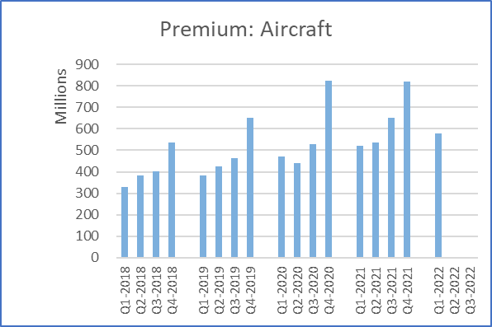 | 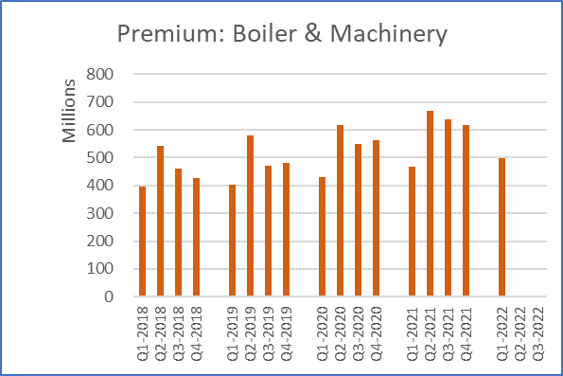 | 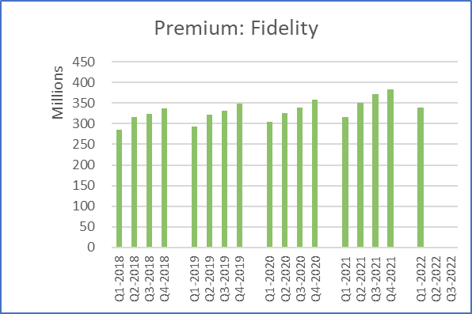
Figure 38 | Figure 39 | Figure 40
Q1-to-Q1 Rolling Average  11.1% 11.8% 14.3%  2021 Premium: $2,530,476,000 | Q1-to-Q1 Rolling Average  6.7% 10.4% 5.8%  2021 Premium: $2,392,002,000 | Q1-to-Q1 Rolling Average  7.6% 8.0% 4.5%  2021 Premium: $1,421,935,000
Table 38 | Table 39 | Table 40
Line of Business Breakout
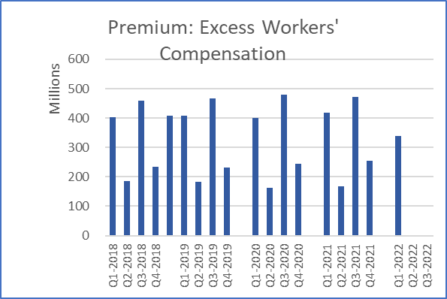 | 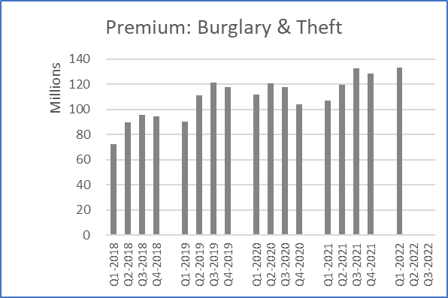 | 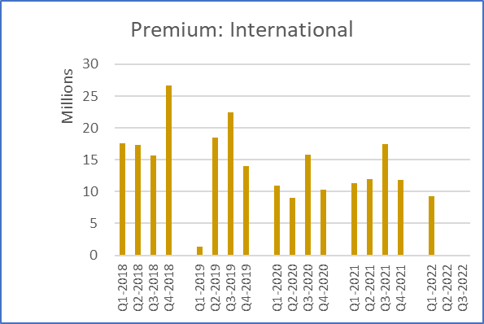
Figure 41 | Figure 42 | Figure 43
Q1-to-Q1 Rolling Average  -19.3% -5.5% -4.4%  2021 Premium: $1,313,620,000 | Q1-to-Q1 Rolling Average  24.4% 14.2% 15.5%  2021 Premium: $487,857,000 | Q1-to-Q1 Rolling Average  -18.5% 8.7% -15.7%  2021 Premium: $52,650,000
Table 41 | Table 42 | Table 43
Line of Business Breakout
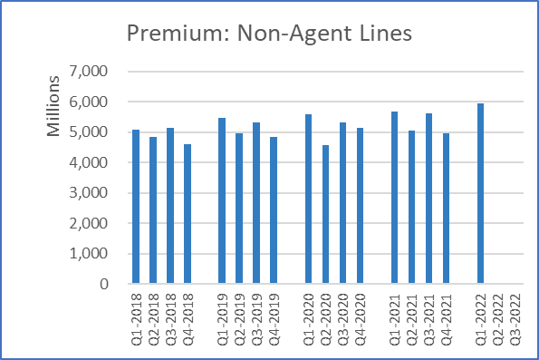
Figure 44
Q1-to-Q1 | Rolling | Average
5.0% | 4.3% | 3.9%
2021 Premium: $21,277,499,000

Table 44
Source: © A.M. Best Company — used by permission.
Appendix #1 – Measuring Premium Growth
Premium growth rates are tracked and measured in 3 ways in the Nebraska 2022-Quarterly P-C Premium Summary – Q1.
The three measures of growth are: Q1-to-Q1, Rolling (12-Months), and Average (4 Years). Three measures are provided because either a short-, medium-, or long-term percentage measure may be the most useful.
- Short-Term: Q1-to-Q1 growth rates tend to be the most volatile but are the most current.
- Medium-Term: Rolling 12-months is a bit more stable but still current.
- Long-Term: Average (4 Years) is still current but the most stable and useful for assessing longer-term trends.
As with the 2021 Nebraska P-C Marketplace Summary, this quarterly Summary uses P-C industry data on the direct insurance business, before reinsurance. As independent agents, this is the marketplace experience for the business we place for our clients. So, premiums used throughout this quarterly Summary are direct premiums, not net premiums or gross premiums. Also, as the quarterly Summary is focused on insurance policy trends in each quarter, written premiums, not earned premiums, are used.
Figures 45-47 below visually show what each percentage conveys, followed by the mathematical formula for computing the growth rate. Figure 45 shows Q1-to-Q1, Figure 46 the Rolling 12-Months, and Figure 47 shows Average 4-Years. United States E&S data is used as an illustration of the calculations, based on the data in the bar charts.
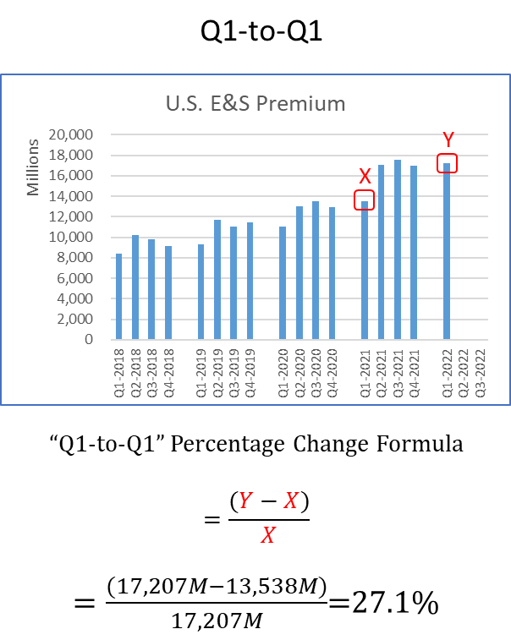 | 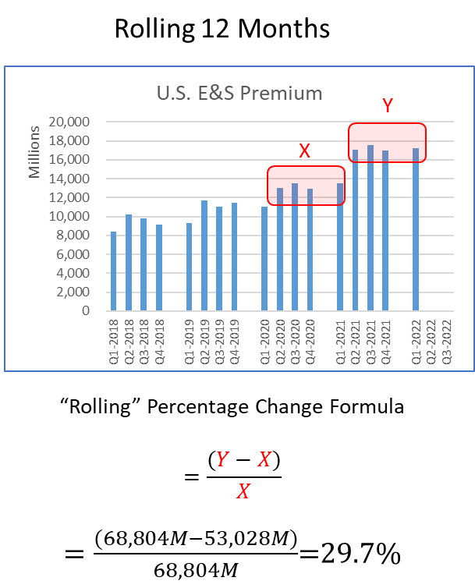 | 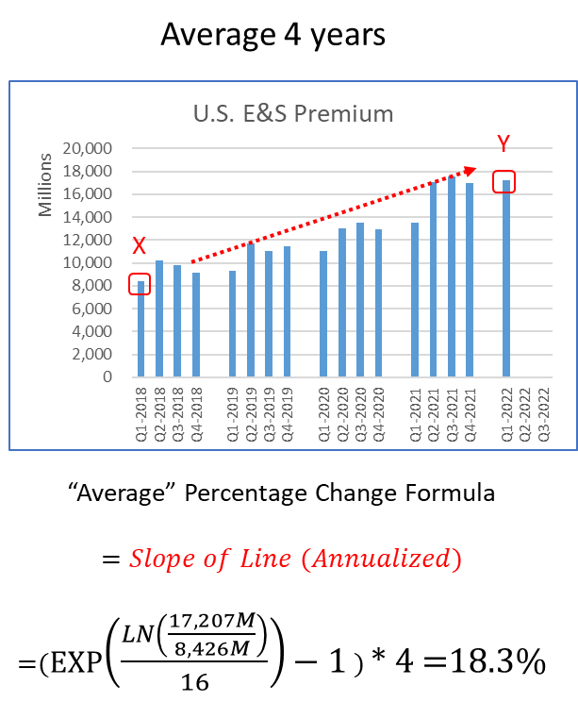
Figure 45 | Figure 46 | Figure 47

Appendix #2 – Annual vs. Quarterly P-C Summaries
There are several important differences in the annual 2021 Nebraska P-C Marketplace Summary vs. the Nebraska 2022 Quarterly P-C Premium Summary – Q1. Those are differences in how lines of business are reported, differences in some premium totals, and differences in the number of years covered. There is also one important similarity between the annual Summary and quarterly Summary. That similarity is how insurers are categorized into distribution styles.
Lines of Business Differences
The lines of business reported by insurers in annual statutory statements are more numerous and detailed than the lines of business reported in quarterly reports. This results in a difference in how lines of business are handled in the annual 2021 Nebraska P-C Marketplace Summary vs. the Nebraska 2022 Quarterly P-C Premium Summary – Q1. An example is, in the State’s annual Summary automobile data is able to be segregated into both commercial and private passenger automobile. In the quarterly Summary, however, commercial and private passenger automobile are combined. Below is a chart that provides a comparison between the treatment of lines of business in the annual vs. the quarterly Summaries. The annual Summary lines of business are listed alphabetically.

Annual P-C Marketplace Summary Treatment | Quarterly P-C Premium Summary Treatment
Accident & Health | In "Non-Agent Lines"
Aggregate Write-ins | In "Non-Agent Lines"
Aircraft (all perils) | Aircraft (all perils)
All Commercial Auto | All Auto
All Private Passenger Auto | All Auto
Allied Perils Only | In "E.C. Perils+Flood+Crop"
Boiler & Machinery | Boiler & Machinery
Burglary & Theft | Burglary & Theft
Commercial Multi-Peril | Commercial Multi-Peril
Credit | In "Non-Agent Lines"
Earthquake | Earthquake
Excess Workers' Comp | Excess Workers' Compensation
Farmowners Multi-Peril | Farmowners Multi-Peril
Federal Flood | In "E.C. Perils+Flood+Crop"
Fidelity | Fidelity
Financial Guaranty | In "Non-Agent Lines"
Fire Peril Only | Fire Only
Homeowners Multi-Peril | Homeowners
Inland Marine | Inland Marine
International | International
Medical Malpractice | Medical Malpractice
Mortgage Guaranty | In "Non-Agent Lines"
Multi-Peril Crop | In "E.C. Perils+Flood+Crop"
Ocean Marine | Ocean Marine
Other Liability (Claims-made) | Other Liability (Claims-made)
Other Liability (Occurrence) | Other Liability (Occurrence)
Private Crop | In "E.C. Perils+Flood+Crop"
Private Flood | In "E.C. Perils+Flood+Crop"
Products Liability | Products Liability
Surety | Surety
Warranty | In "Non-Agent Lines"
Workers' Compensation | Workers' Compensation
Total Premium Differences
A detail-oriented reader may notice some slight differences in premium totals between the what is reported in the 2021 Nebraska P-C Marketplace Summary vs. the Nebraska 2022-Quarterly P-C Premium Summary – Q1. The reason is that in annual statutory statements insurers provide a page that is known as Statutory Page 14. This Page 14 provides premium data and a convenient premium total for each of the 50 states and the District of Columbia.
With the quarterly reports there is no Statutory Page 14. Instead, to get to premium totals for each insurer each quarter, a different page called Schedule T is used. That page only provides a total premium that includes the 50 states and the District of Columbia, plus United States territories, Canada and alien jurisdictions. The addition of the United States territories, Canada and alien jurisdictions in the total adds about 1.5% to the total premiums.
For clarity, below are the total premiums in the United States for all lines of business from the annual 2021 Nebraska P-C Marketplace Summary, and the aggregation of the 4 quarters of the same year from the Nebraska 2022 Quarterly P-C Premium Summary – Q1.
All Lines of Business | 2021 Annual Summary  (Statutory Page 14) | Quarterly Summaries  (Schedule T) | Difference (*)
United States | $785,288,646,000 | $798,849,370,000 | $13,560,724,000 (1.5%)
(*) Difference is premiums in Alien jurisdictions (40%), Canada (33%), Puerto Rico (20%) and remainder Guam, U.S. Virgin Islands and Norther Mariana Islands.
Time Period Differences
In the annual 2021 Nebraska P-C Marketplace Summary the most recent 5 years of data are presented. The Nebraska 2022-Quarterly P-C Premium Summary – Q1 uses the most recent 4 years and one additional quarter of data (17 quarters). A.M. Best Financial Suite’s quarterly data contains 18 quarters, which is less than 5 years, as opposed to the 11 years of data available in A.M. Best Financial Suite’s annual data.
Distribution Styles Similarities
The same approach to classifications of insurers by distribution style is used in the Nebraska 2022-Quarterly P-C Premium Summary – Q1 as in the annual 2021 Nebraska P-C Marketplace Summary. As with the annual Summary, there are 6 classifications of insurers into distribution styles. They are listed below. The annual Summary contains more information on the classification of insurers, based on reported Marketing types. Interested readers should refer to the annual Summary and its Appendix #2: Distribution Style Classifications. Just like in the annual Summary, this quarterly Summary classifies insurers who generally distribute through Independent Agents as the combination of insurers distributing through IA or Broker, MGA, and IA-Mixed.
- IA or Broker
- MGA
- IA-Mixed
- Direct
- Exclusive-Captive
- Other Distribution
Analysis Provided by Real Insurance Solutions Consulting
This Nebraska 2022-Quarterly P-C Premium Summary – Q1 has provided the reader with both visual and numeric presentations of the Nebraska P-C premium data for the first quarter in the current year, 2022. It is a benefit of your membership with the Independent Insurance Agents of Nebraska. All questions and comments, or need for further analysis, are welcomed at the contact information below.

Real Insurance Solutions Consulting, LLC
Paul A. Buse, Principal
www.realinsurancesc.com
301-842-7472

